Data Analysis with SQL, Python, Jupyter Notebook

To analyze the case - study data after cleaning the data via MS Excel, tools like SQL, Python along with Pandas library and Jupyter Notebook is used.

Since SQL cannot be run directly in Jupyter Notebook, we create a dataframe for the CSV file using Pandas library and then create a table in SQL and connect the dataframe with the table.

The following steps are involved to import and connect the data in SQL database:

import pandas as pd

import sqlite3

data = pd.read_csv("Data Analysis - Case Study - Data.csv", header = 0)

For analyzing the data in a much easier way, the columns with improper data format are removed to avoid confusion.

data = data.drop(['order_time', 'store_reach_time', 'start_delivery_time', 'completed_cancelled_time', 'order_rating'], axis=1)

Now the data framework is connected to SQL server via SQLITE3 available in Jupyter Notebook. A database named ‘dunzo_da_assig’ is created to store the table.

db_conn = sqlite3.connect("da_assig.db")

c = db_conn.cursor()

Now a table named ‘data’ is created with matching columns as of dataframe.

c.execute(

"""

CREATE TABLE data (

order_timestamp TEXT,

order_timeslot TEXT,

order_month_num INTEGER,

order_month TEXT,

order_day_of_week TEXT,

user_id INTEGER,

pickup_geo TEXT,

drop_geo TEXT,

order_id INTEGER,

products TEXT,

num_products INTEGER,

store_reach_timestamp TEXT,

start_delivery_timestamp TEXT,

completed_timestamp TEXT,

completion_flag TEXT,

difference_delivery_time INTEGER,

order_ratings INTEGER,

product_amount INTEGER,

delivery_charges INTEGER,

discount INTEGER,

PRIMARY KEY (order_id)

);

"""

)

The dataframe and table will be connected using the to_sql function:

data.to_sql('data', db_conn, if_exists='append', index=False)

**Completion_Rate:**

To determine the completion_rate from the available data, following query is used:

pd.read_sql("SELECT

SUM(CASE completion_flag WHEN 'YES' THEN 1 ELSE 0 END) * 100.0 / COUNT(completion_flag) as completion_rate

from data",db_conn)

**Completion Rate across day of week and timeslot:**

Day of week:

pd.read_sql("SELECT count(*) as Num_orders, order_day_of_week

from data

where completion_flag = 'YES'

group by order_day_of_week

order by Num_orders DESC",db_conn)

Timeslot:

pd.read_sql("SELECT count(*) as Num_orders, order_timeslot

from data

where completion_flag = 'YES'

group by order_timeslot

order by Num_orders DESC",db_conn)

**Segmenting the users based on their order behavior:**

Number of products purchased by users vary at different times. To segment users based on number of products purchased:

pd.read_sql("SELECT count(*) Num_Customers, CASE

WHEN num_products BETWEEN 1 AND 4 THEN 'Essential buyer' WHEN num_products BETWEEN 5 AND 10 THEN 'Mid buyer'

WHEN num_products BETWEEN 11 AND 17 THEN 'Heavy buyer'

ELSE 'Bulk buyer' END as Types_Customers

from data

group by Types_Customers

order by Num_Customers DESC",db_conn)

The key metrics available from the following data are Average revenue per user (shows how much each customer is spending for purchase via the platform), Retention rates (calculates how many customers would be loyal to the company), Number of events (number of times a customer orders from the platform, or uses the app), Conversion rate (how many times customers actually buys any order via the app/website)

**Retention Rate:**

To calculate the retention rate for each month, the below query is used:

pd.read_sql("Select first,

SUM(CASE WHEN month_number = 0 THEN 1 ELSE 0 END) AS January,

SUM(CASE WHEN month_number = 1 THEN 1 ELSE 0 END) AS February,

SUM(CASE WHEN month_number = 2 THEN 1 ELSE 0 END) AS March,

SUM(CASE WHEN month_number = 3 THEN 1 ELSE 0 END) AS April,

SUM(CASE WHEN month_number = 4 THEN 1 ELSE 0 END) AS May,

SUM(CASE WHEN month_number = 5 THEN 1 ELSE 0 END) AS June,

SUM(CASE WHEN month_number = 6 THEN 1 ELSE 0 END) AS July,

SUM(CASE WHEN month_number = 7 THEN 1 ELSE 0 END) AS August,

SUM(CASE WHEN month_number = 8 THEN 1 ELSE 0 END) AS September

from (SELECT m.user_id,m.order_month_num,n.first as first,m.order_month_num-first as month_number

from (SELECT user_id, order_month_num FROM data GROUP BY user_id,order_month_num) m,

(SELECT user_id, min(order_month_num) AS first FROM data GROUP BY user_id) n

where m.user_id=n.user_id) as with_month_number

group by first

order by first",db_conn)

**Average Revenue per account**:

pd.read_sql("SELECT order_month,

sum(product_amount + delivery_charges) AS monthly_revenue, count(DISTINCT user_id) AS users,

(sum(product_amount + delivery_charges) / count(DISTINCT user_id)) AS average_revenue

FROM data

GROUP BY order_month",db_conn)

**Customer LifeTime Value:**

To calculate Customer LifeTime Value(LTV), we need few other values to be calculated.

Average purchase value(APV) = total revenue / total number of purchases

Average purchase frequency rate(APFR) = total users / total number of purchases

Average customer value(ACV) = APV * APFR

Average customer lifespan(ACL) = sum of user lifespan / total number of users

Customer Lifetime Value(LTV) = ACL * ACV

pd.read_sql("With purchases_by_month as

(SELECT user_id, order_month, SUM(product_amount + delivery_charges) as total_purchases_that_month

FROM data

GROUP BY 1, 2),

ACV as (SELECT AVG(total_purchases_that_month) as ACV

From purchases_by_month),

max_and_min_purchases as (SELECT user_id,

MAX(product_amount + delivery_charges) as most_recent_purchase, MIN(product_amount + delivery_charges) as first_purchase

FROM data Group by 1),

Lifespan_calculation as (SELECT

(most_recent_purchase - first_purchase) / 30.0 as months_in_between_purchases FROM max_and_min_purchases),

average_lifespan as (SELECT AVG(months_in_between_purchases) as ACL

FROM Lifespan_calculation)

SELECT ACV * ACL as LTV

From average_lifespan

join ACV on 1 = 1",db_conn)

**Relationship between columns via Visualization:**

1. Number of users vs Number of products purchased

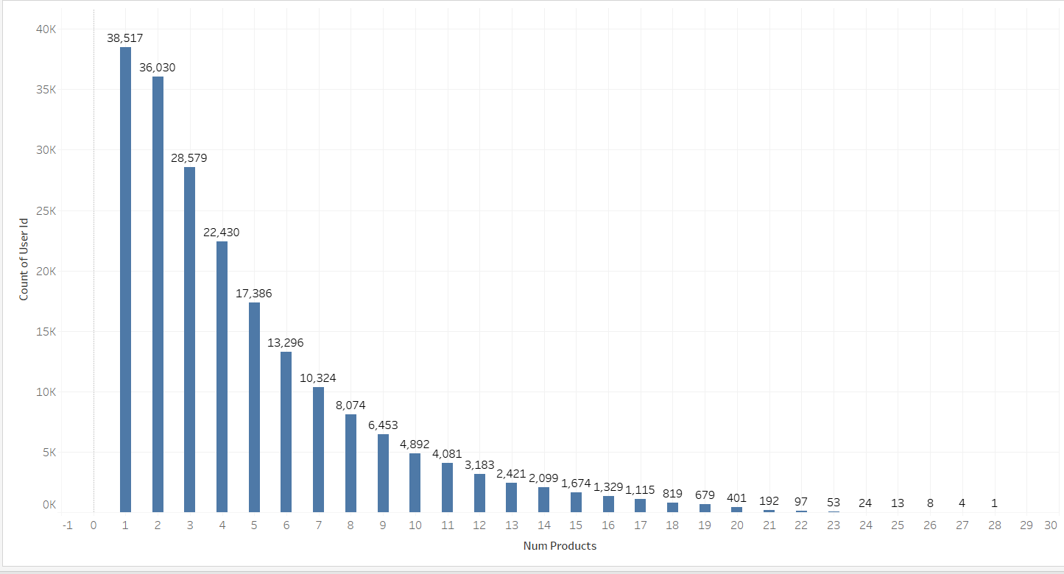

The graph shows a constant decrease in the number of products purchased with respect to the number of users.

1. Discount rate vs Month

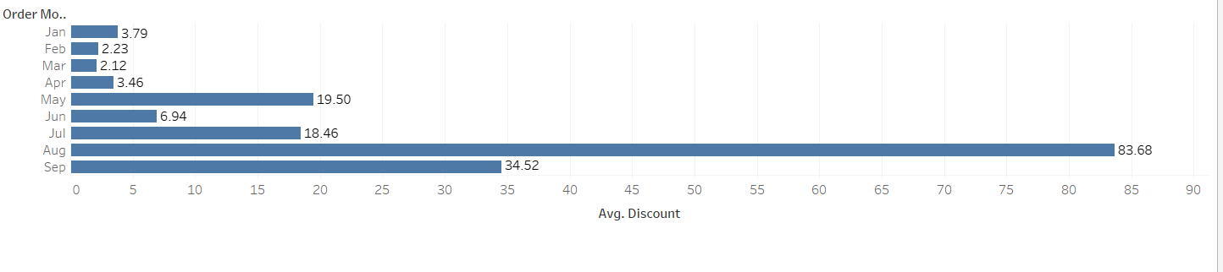

We could see that the discount rates were lower at the start of the year while as the year progressed, there were a decent amount of discounts provided. August records the highest amount of discounts provided.

1. Order ratings correlation with other data-points

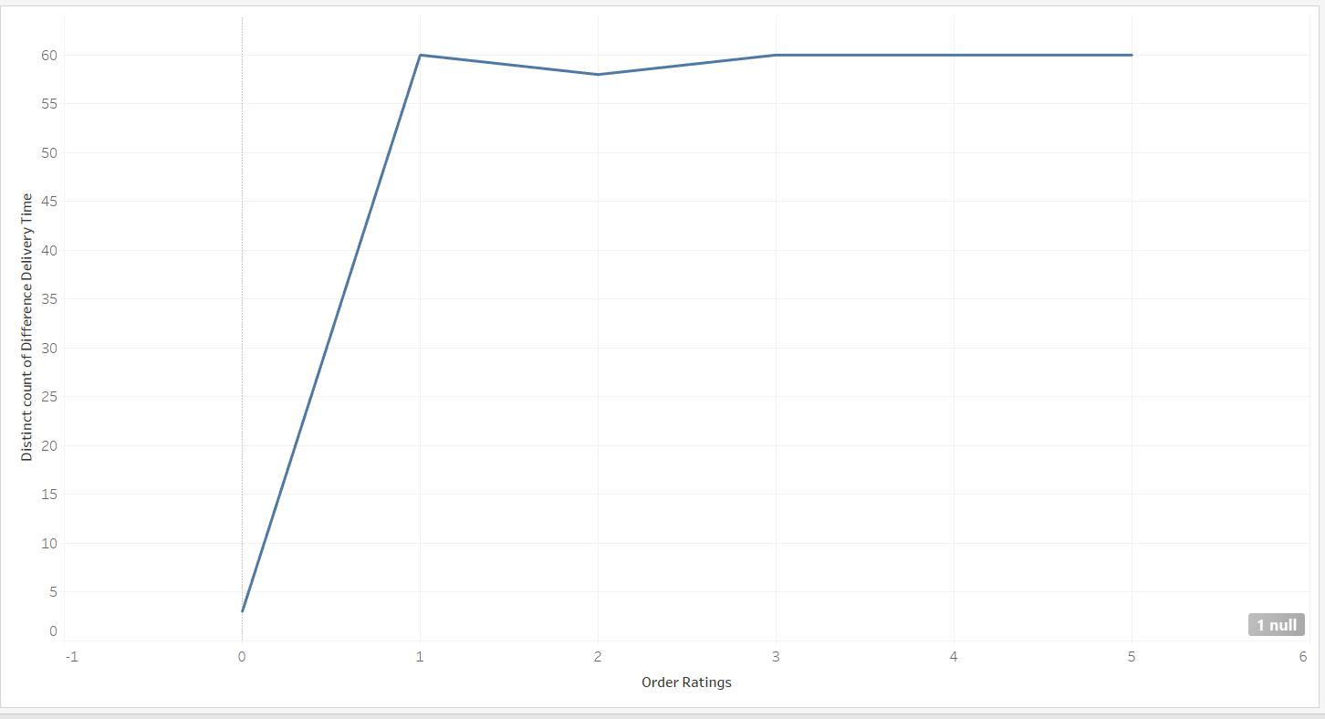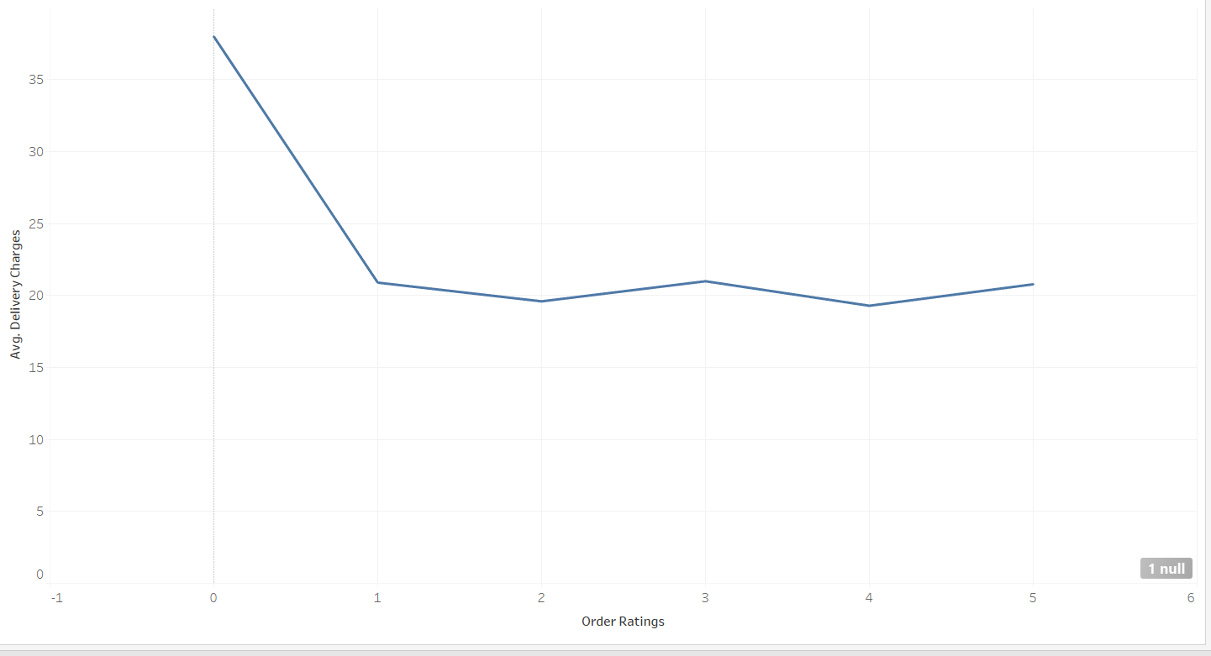

From the above 2 graphs, it could be concluded that the delivery charges and difference in delivery time does not impact on ratings.

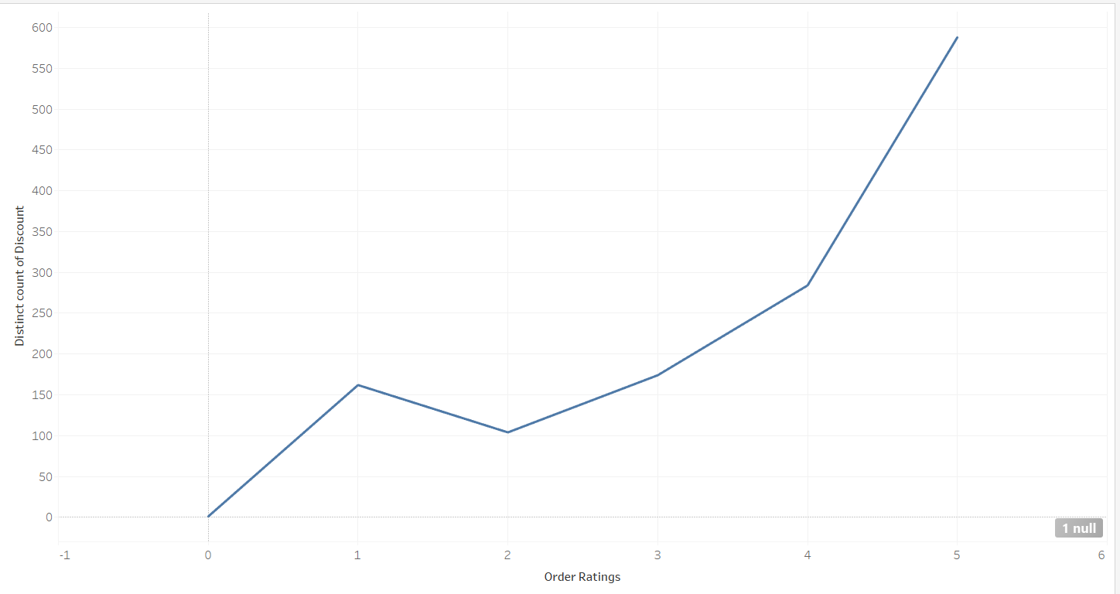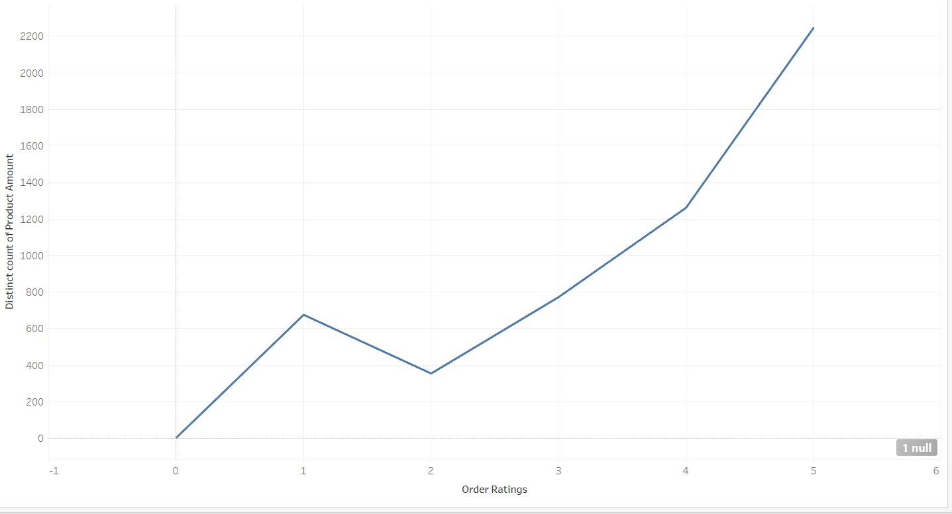

But there are 2 data points which are impacting the order ratings - discount rates and total product amount.

Higher the discount, higher the rating

Likewise, higher the value of the products, higher the rating.

**Propose how can we improve ratings as well as customer satisfaction:**

From the analysis, it could be concluded that the discount rates and amounts of products have an impact. Hence more discount offers should be provided for new customers.

To raise the retention rate, more offers like combo offers or discount offers should be provided to loyal customers.

To prevent the churn rate, a survey should be held to know the difficulties faced by customers. Also any reason why the product was canceled sometimes.